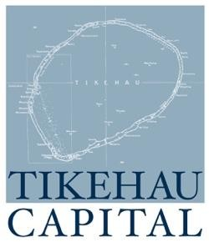

**PRESS RELEASE**

**Tikehau Capital announces the closing of the sale of its stake in Ecotel Chomette Favor**

**Paris, 6 April 2017 - Tikehau Capital announces the sale of its stake in Ecotel Chomette Favor (E.CF) to Naxicap Partners. Tikehau Capital is realising gross pre-tax capital gains of EUR 18.2 million from the sale, i.e. 2.8 times its investment after fees and costs.**

Tikehau Capital initially invested EUR 10 million in E.CF in June 2011 (via Salvepar) alongside the majority shareholder, Weinberg Capital Partners, and the management team led by Thierry Drecq.

E.CF is the European leader in the distribution of small equipment to professionals in the hospitality and catering sectors. E.CF is firmly established in Europe and has more recently expanded internationally.

**About Tikehau Capital**

Tikehau Capital is an asset management and investment group which manages approximately €10bn of assets, with shareholders’ equity of €1.5bn. The group invests in various asset classes (private debt, real-estate, private equity and liquid strategies), including through its asset management subsidiary Tikehau IM, on behalf of institutional and private investors. Controlled by its managers, alongside leading institutional partners, Tikehau Capital employs 170 staff in its Paris, Milan, Brussels, London and Singapore offices.

Tikehau Capital is listed on Euronext Paris, compartment A (ISIN code: FR0013230612; Ticker: TKO.FP)

[www.tikehaucapital.com](http://www.tikehaucapital.com)

**Press Contacts :**

Tikehau Capital : +33 1 40 06 18 40

Julien Sanson - jsanson@tikehaucapital.com

Image 7 : + 44 781 864 18 03

Leslie Jung - ljung@image7.uk.com